RICE: Real-Time Interactive Collaborative Editor

Daniel Adler, Zachary Shelton and Shannon McGovern
Department of Computer Science and Networking
Wentworth Institute of Technology
Boston, MA 02115, USA
{adlerd, sheltonz, mcgoverns2}@wit.edu

Abstract— Real-time interactive collaborative editors enable users to work together simultaneously on a single document, and incorporate each other’s changes in real time. This is used throughout every one of Google’s applications, such as Google Docs, Google Slides, Google Sheets, etc. Creation of a real-time collaborative editor similar to the concept of Google Docs provides the opportunity for students/professionals learning the concepts in the technical field to put their knowledge to the test and create one from the ground up. While this application is not as sophisticated as those previously implemented across the Internet, it proves the proof of concept and understanding that what is taught throughout the network programming course is applicable in real-world scenarios.
Keywords— Java, Client, Server, Collaboration

Introduction
Five female scientists from around the world are currently working on a collaborative research effort that focuses on malignant melonma. This cancer is the most aggressive form of skin cancer, and the trend in diagnosis shows signs of only increasing from this point forward. In 2013 alone there were 13,000 new cases of Melonma in the United Kingdom, along with 2,000 deaths from this cancer. The five female scientists are based at the Spanish National Cancer Research Centre, The Wistar Institute, the University of Edinburgh’s Institute of Genetics and Modular Medicine, the Perelman School of Medicine at the University of Pennsylvania, and the Ichan School of Medicine at Mount Sinai, New York City. In order for this research team to work effectively despite the logistical issues of distance, the ability to work simulataneously on their work through real-time interactive collaborative editor platforms, provides a solution. It is predicted that by 2030, Melonma will be amongst the top 5 most occuring cancers in the United Kingdom alone, proving to be a serious time-sensitive issue. Therefore, the abilty to continue their work and maintain on the same page to ensure productivity is essential. These five researchers are able to continue their work and accomplish the project’s four main goals of; “identifying biomarkers of active metastasis”, “defining how tumour cells can become “dormant,” and why at some point, they get “awakened”, “to validate treatments that could attack both dividing and silent melonma cells”, and “to mentor and empower new female researchers in the melonma field” by keeping up with collaboration and new findings depsite being across the world from each other [1]. If the world was not as technologically advanced as it is today, then the possibility for ground-breaking new findings regarding one of the most prevelant forms of cancer that plagues people may not be for many more years to come. If it were not for real-Time interactive collaborative editors such as Google Docs, their progress would move at an extremely slower rate. The premise behind what these scientists have to use in order to accomplish their goals can be boiled down to something much simpler than cancer research. It can be applied to a spreadsheet of shifts for work that your employees can see, a group project worked on outside of class, and a multitude of more possibilities. These examples prove something like RICE is applicable to the real world, and how collabortive platforms such as RICE serve a real purpose and have beneficial outcomes as a result of such purpose.

rice
We created a client-server program where all of the text on the page stays unless someone deletes it. Once the document is shared, a copy of it is sent to the server and the server handles the online backup as well as the coordination between clients. This is to ensure all changes are displayed to each client. The server then syncs the changes between all of the different users that have the document open, and the updates occur on each client’s screen in real time. We addressed network latency issues and ensured all editors involved were able to maintain synchronization.
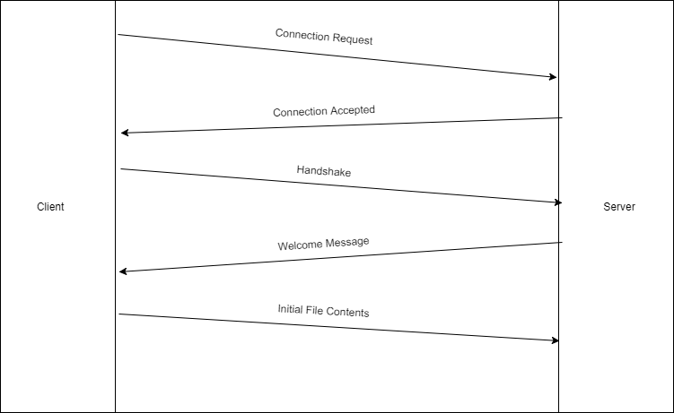
- Concept of How Connection is Established Between Client(s) and Server.

Operational Transformation

In order to ensure there is an accurate display of synchonized changes, the implementation of operational transformation had to occur. This needed to be implemented, because without it there is a problem if two users are editing the same aspect of the document at the same time. The two users could both be making different changes, and could ultimately end up with different versions of the changes. To combat this issue, operational transformation provides the opportunity for replicated document storage. This means, each user, or client, has their own copy on which they operate, and the changes are then shared to the rest of the clients. When another client receives the shared changes, it transforms the changes before executing them. This technique is actually implemented in all collaborative Google platforms as of 2009, and is the core principle behind their ability to permit synchronization to be maintained after executing all operations. It was first introcuded as Google Wave, and then was later renamed to Apache Wave [3].
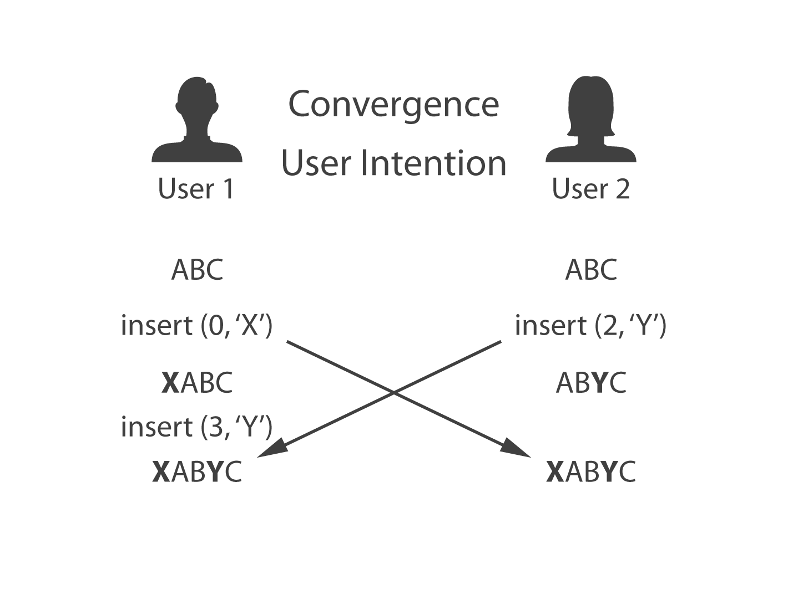
- Example of the Issues Operational Transformation Can Solve.

Solution
First and foremost, we had to understand how to create communication between the client(s) and the server. To do this, the understanding of the difference between a client and a server had to be established. A client can be defined as “a program or a process which connects to another program (the server) and lets it carry out a specific task. In particular, it might require supplying some data from the server” [4]. A server can be defined as “a program or a process which provides services for clients. For example, it might supply some data or a result or processing data to clients” [4].

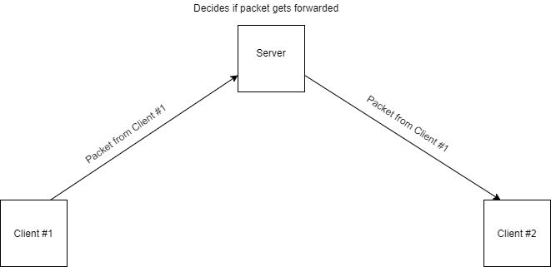
- Concept of How Clients Talk to Each Other.
When one client does anything once a document is shared it sends a packet with data pertaining to the operation to the server. The server reads this packet and its data and decides if the packet should be forwarded to the rest of the clients. If yes, the server copies the packet data over and sends it to the all the other clients connected. If not, the packet is consumed and ends its life cycle at the server.
We enabled our program to be able to be run simultanously, which for demonstration purposes is extremely effective. When demonstrating the success of the project, the audience has the ability to view both the server and client running at the same time. Additionally, two clients can be run at the same time to prove that as you type as one client, the contents of what you typed are shown in the other client’s document.

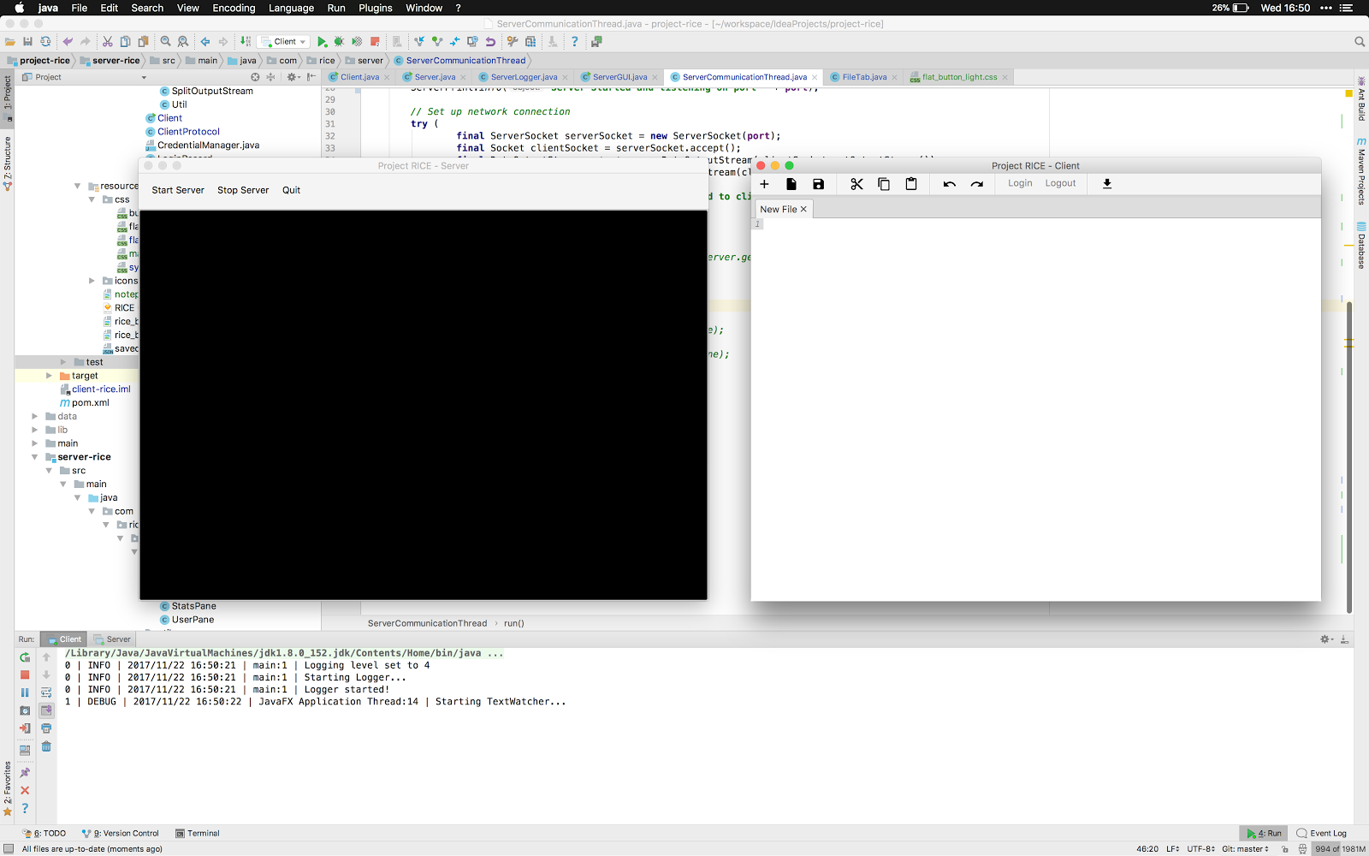
- Client and Server Are Able to be Run Simultaneously from the Same Computer.

That being said, they can also be run separately. Depicted below is just the server running in a terminal. It allows the administrator to see what the server is currently doing so that any issues can be addressed.
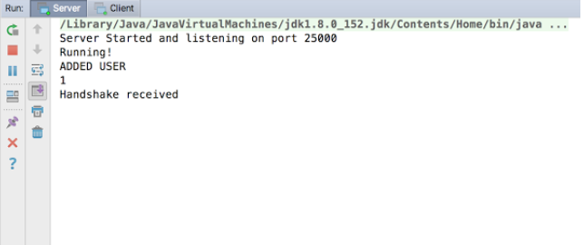
- Server Running

Just as the server can be run by itself, the client can also be run by itself. Depicted below is the client with a document queued up in the main view.

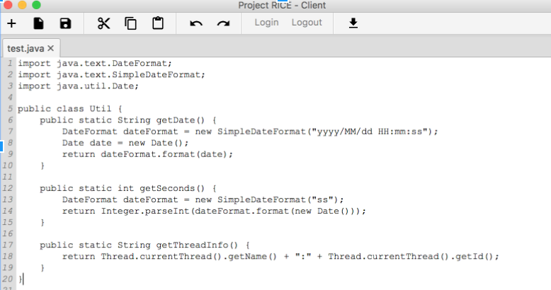
- Client Code

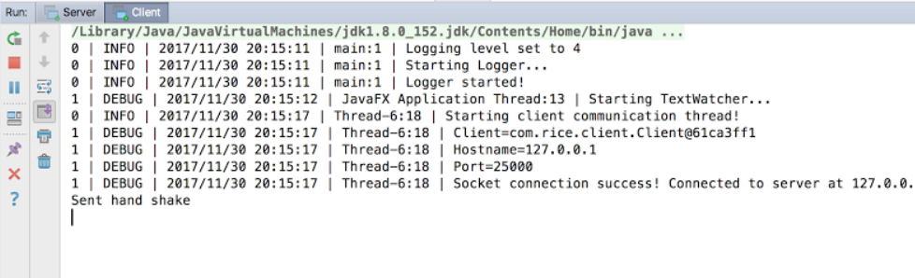
- Client Running
The issue of latency was a hurdle to be tackled in the creation of RICE. It is not an issue we only struggled with, rather one that already prominent platforms struggled with initially as well. Latency is the delay before a transfer of data begins following an instruction for a transfer [5]. With respect to our program, the issue of latency causes things to get out of sync between clients and the server. For example, if you type characters at a faster rate, it doesn’t register every character. To fix this issue, we would need to send time data along with the modified packets so that the client can figure out the order in which the text needs to be edited. In order to do this, it would make sense to attach a timestamp to the modify packet when the client sends it, so all other clients can parse when the change was actually made.

Future Plans
As a result of our venture, we successfully developed a Real-Time, Interactive, Collaborative, Editor, which functions similarly to that of widely used and respected platforms such as Google Docs. Our main goal was to create a basic client-server model to provide “proof of concept” of the understanding of methods that enable Google Drive to function as a collaborative platform. Given time, this research and program could be improved and expanded upon to be more than just simply a proof of concept, and potentially be put to use amongst students with respect to working on group projects for coding for example. Additionally, with more time we would have added more features to the RICE project, fortunately there is an endless amount of time in the future. The next step would be to focus on adding user authentication to add some security features to the program. Right now, anyone could utilize this program and become a client and for our purposes this is not a huge concern, however if this were to be put to use outside of just the original purpose of being a final project, it could and would become an issue. Additionally, we would remove the extra hop to the server by using a peer to peer connection via User Datagram Protocol hole punching. This would enable clients to communicate directly and not have to go through a server to “approve” and then share the changes made by each client. Rather, the clients would be able to work directly with each other to make and work with changes. Some aspects of the program that were not prioritized because they did not necessarily hinder the main function include syntax highlighting and cursor location of other users. Both are preferred when working collaboratively on a document because they provide each user with more knowledge about what is occurring with the other users. Syntax highlighting would enable each user to see who made which changes, and knowing the cursor location of each user would prevent changes being made to the same aspects of the document if you could see where each user is working.
The program itself is very simple, and provides just the meat of what the project could consist of. As the program for this basic collaborative platform grows, we plan on building upon what we have created to potentially generate a product that is up to par with that of existing collaborative platforms.

Conclusion
Being born into a generation that was already so technologically advanced put us at both an advantage, and disadvantage. The advantage being that we have opportunities to explore realms that were foreign to the world ten years before we came into existence. Communication had just begun to dive into the creation of cellular telephones in the 1990’s, yet here we are today writing code to enable people to potentially work simultaneously together from across the world. On the other hand, the disadvantages include the principle of face-to-face communication having dwindled so much that it is now something that is looked upon as appreciated because of its lack of presence in today’s day and age. This project enables this disadvantage to continue to fester, however just because it can be viewed as a disadvantage does not mean all of the adverse effects are negative ones. Additionally, because we were born into advanced technology’s existence, it is often taken for granted. Creating something that is often used in everyday life ranging from elementary school purposes to on the job requirements, brings to light the regard we should have for such things that already existed. We created an extremely simplified version compared to what Google Docs or other collaborative platforms consist of, and it was still a decent amount of work to get the program working properly. That being said, not only was an understanding of how the networking aspect of something most students use every day works, but also an understanding of the degree of work went in and still is put in to ensuring such a platform continues to be useable.

References
[1] “Five Female Scientists Are Working on Ground-Breaking Melanoma Research.” The University of Edinburgh, 20 June 2017, www.ed.ac.uk/igmm/news-and-events/news-2017/female-scientists-working-melanoma-research.

[2] Kriskovic, Domagoj. “Real-Time Collaboration Issues and Solutions.” Blog · Codeanywhere, Blog &Middot; Codeanywhere, 21 Feb. 2015, blog.codeanywhere.com/real-time-collaboration-issues-and-solutions/.

[3] “Apache Wave (Incubating).” Apache Wave - Welcome to Apache Wave (Incubating), incubator.apache.org/wave/about.html.

[4] Krzysztof Barteczko, Wojciech Drabik, Bartłomiej Starosta. “Client-Server Programming with Sockets.”Client-Server Programming with Sockets, edux.pjwstk.edu.pl/mat/268/lec/lect8/lecture8.html.

[5] Latency.” Dictionary.com, www.dictionary.com/browse/latency.

